**Vivekanand Education Society's Institute of Technology**



**Department of Computer Engineering**

**Group No: 29**

**Date:- 02/08/2024**

**Project Synopsis (2024-25) - Sem V**

RescueNow

Mrs Lifna.C.S

Asst. Professor, CMPN

Eshan Vijay Rahul Dudani

D12C/19 D12C/18

[2022.vijay.eshan@ves.ac.in](mailto:2022.vijay.eshan@ves.ac.in) [2022.rahul.dudani@ves.ac.in](mailto:2022.rahul.dudani@ves.ac.in)

Yash Jha Sumeet Janyani

D12C/33 D12/32

[2022.yash.jha@ves.ac.in](mailto:2022.yash.jha@ves.ac.in) [2022.sumeet.janyani@ves.ac.in](mailto:2022.sumeet.janyani@ves.ac.in)

**Abstract:**

In the critical moments following a traffic accident, timely medical intervention can make the difference between life and death. However, delays often occur due to lack of immediate reporting, uncertainty about the nearest suitable hospitals, and inefficient coordination among emergency services. To address these challenges, we propose RescueNow, a mobile application designed to streamline accident reporting and enhance emergency response efficiency.

**Introduction:**

In the event of a traffic accident, immediate and effective response is crucial for ensuring the best possible outcomes for victims. However, significant delays often occur due to various factors, including the lack of instant accident reporting, the difficulty in identifying the nearest suitable medical facilities, and the challenges in coordinating emergency services. These delays can be detrimental, sometimes resulting in loss of life or worsening of injuries.

RescueNow is a mobile application designed to address these critical issues by providing a streamlined platform for accident reporting and emergency response. The application empowers passersby to quickly and efficiently report accidents, assess the severity, and automatically notify the nearest hospitals equipped to handle the situation. By facilitating real-time communication and coordination among all stakeholders, including casualty teams, hospitals, family members, and law enforcement, RescueNow aims to minimize response times and optimize medical care for accident victims.

Through RescueNow, we aim to improve the overall efficiency of accident management and ensure that victims receive timely and appropriate medical attention and ultimately save lives.

**Problem Statement:**

Timely medical intervention is critical in the aftermath of traffic accidents to prevent fatalities and mitigate injuries. However, several challenges hinder efficient emergency response:

**1. Delayed Accident Reporting:** Passersby often struggle with how and where to report accidents quickly, leading to delays in initiating emergency response.

**2. Identifying Suitable Hospitals:** Victims are sometimes taken to hospitals that are either not equipped to handle the severity of their injuries or are at capacity, resulting in further delays and suboptimal care.

**3. Inefficient Coordination:** There is a lack of efficient communication and coordination among passersby, emergency services, hospitals, and victims families, which can lead to chaotic and ineffective rescue operations.

**4. Vital Monitoring:** Consistent and timely monitoring of victims vitals from the accident scene to the hospital is often inadequate, affecting the quality of care provided.

To address these issues, we propose RescueNow, a mobile application designed to streamline the process of accident reporting and enhance the efficiency of emergency medical responses. RescueNow aims to ensure that victims receive timely and appropriate medical care by facilitating immediate accident reporting, identifying the nearest suitable hospitals, and enabling real-time coordination among all stakeholders involved in the rescue operation.

**Proposed Solution:**

RescueNow addresses the challenges of accident reporting and emergency response through the following integrated features:

**1. Accident Reporting:**

Passersby can quickly report accidents by uploading an image of the victim, rating the severity of the incident, and providing the location through GPS tracking.

Upon submission, a unique incident ID is generated, creating a comprehensive timeline for the event.

**2. Hospital Notification:**

The app identifies and lists the nearest hospitals based on the accident location and severity of the injuries.

Hospitals receive real-time notifications about the incident, allowing them to prepare for the victim's arrival and ensure that appropriate resources and staff are ready.

**3. Coordination with Casualty Teams:**

The nearest suitable hospital dispatches a casualty team to the accident site.

Casualty team members update their status in real-time, record the victim's vitals, and manage the transportation of the victim to the hospital.

**4. Communication and Tracking:**

The app facilitates communication with the victim's family, providing updates and images of the victim and their hospital location.

If necessary, the app allows the casualty team to notify the police about the incident.

**5. Real-Time Updates and Monitoring:**

The app continuously updates the victim's vital records and the actions of the casualty team throughout the rescue and treatment process.

A centralized platform is provided for all stakeholders, ensuring coordinated efforts and timely responses.

By integrating these features, RescueNow aims to minimize response times, improve resource allocation, and ensure that victims receive prompt and effective medical care.

**Methodology:**

The methodology for developing RescueNow involves several key stages, from system design to implementation and testing. Here’s a step-by-step approach:

1. Requirement Analysis:
   * Gathering detailed requirements from stakeholders, including passersby, hospitals, casualty teams, and law enforcement.
   * Define functional and non-functional requirements.
2. System Design:
   * Design the architecture of the application, including frontend, backend, and database components.
   * Creating detailed wireframes and user interfaces for the mobile app.
   * Develop API specifications for communication between the frontend and backend.
3. Development:
   * Frontend Development:
     + Developing the mobile application using a framework such as React Native or Flutter.
     + Implementing features for accident reporting, severity rating, and location tracking.
     + Integrating real-time updates and notifications.
   * Backend Development:
     + Setting up the server environment using technologies like Node.js with Express or Django.
     + Implementing APIs for handling accident reports, hospital notifications, and real-time updates.
     + Developing logic for identifying suitable hospitals and managing incident timelines.
   * Database Setup:
     + Designing and implementing the database schema for storing accident reports, hospital information, and vitals records.
     + Using a database like MongoDB or Firebase for real-time data handling.
4. Integration:
   * Connecting frontend components with backend services and database.
   * Ensuring seamless data flow and real-time synchronization between the app and server.
5. Testing:
   * Performing integration testing to ensure all parts work together as expected.
   * Testing the app on different devices and platforms for compatibility.
   * Gathering user feedback and performing user acceptance testing.
6. Deployment:
   * Deploying the backend server on a cloud platform like AWS or Heroku.
   * Publishing the mobile application on Google Play Store and Apple App Store.
7. Maintenance and Updates:
   * Monitoring the application’s performance and fixing any issues that arise.
   * Updating the app based on user feedback and technological advancements.

**Block Diagram:**

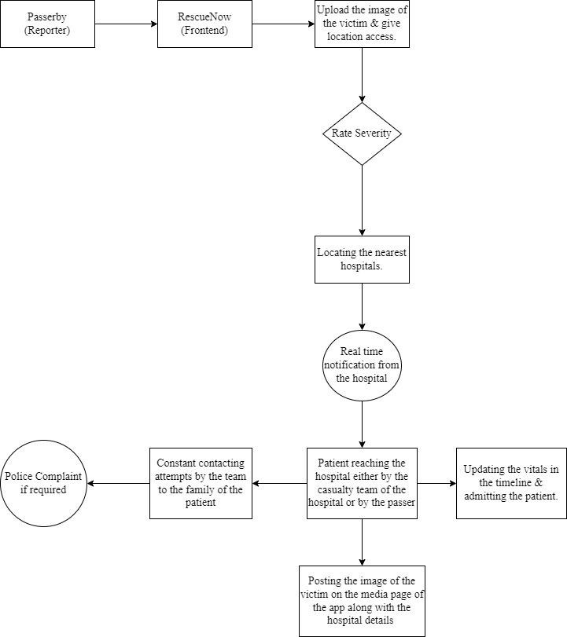

**Ideology:**

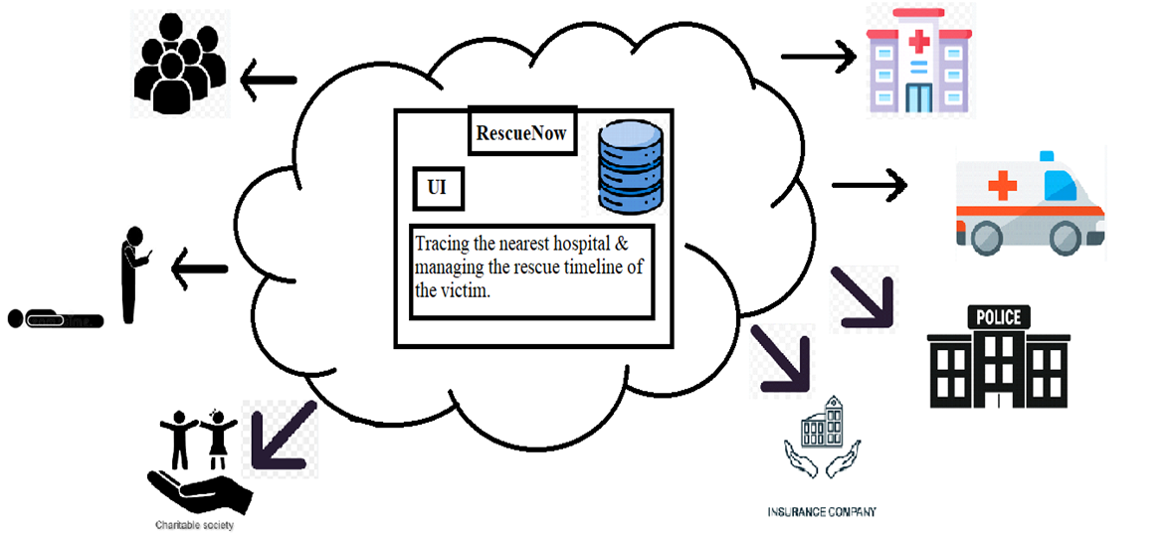

**Hardware, Software and Tools Requirements:**

**Hardware Requirements**

1. For Development:

**Development Machines:**

Processor: Intel i5 or higher (or equivalent AMD processor)

RAM: 8 GB or more

Storage: 256 GB SSD or higher

Mobile Devices: Smartphones and tablets for testing (iOS and Android)

2. For Deployment:

**Server:**

Processor: Multi-core server-grade processor

RAM: 16 GB or more

Storage: 1 TB SSD or more, scalable based on data needs

Network: Reliable high-speed internet connection

**Software Requirements :**

Frontend Development : Flutter.

Backend Development : Node.js, Python, Firebase.

Database Management System : MongoDB.

**Proposed Evaluation Measures:**

To ensure **RescueNow** effectively meets its objectives and performs as intended, various evaluation measures should be implemented. These measures will assess the functionality, usability, performance, and impact of the application.

#### **1. Functional Testing**

* **Feature Verification**: Test all core features of the app, including accident reporting, severity rating, location tracking, real-time notifications, and hospital coordination, to ensure they work as specified.
* **API Testing**: Verify that APIs for data exchange between the mobile app, backend server, and database are functioning correctly and handling data as expected.

#### **2. Usability Testing**

* **User Experience (UX)**: Conduct usability testing with a sample of target users (passersby, casualty teams, hospital staff) to evaluate the app's ease of use, intuitiveness, and overall user satisfaction.
* **User Interface (UI)**: Assess the design and interface of the app for clarity, accessibility, and responsiveness across different devices and screen sizes.

#### **3. Security Testing**

* **Data Security**: Assess the app for vulnerabilities and ensure that sensitive data (e.g., personal information, medical records) is securely encrypted and protected.
* **Authentication and Authorization**: Test the app’s authentication mechanisms and access controls to prevent unauthorized access to sensitive features and data.

#### 

#### 

#### 

#### **4. Field Testing**

* **Real-World Scenarios**: Conduct field tests in real-world environments to evaluate how the app performs in actual accident scenarios, including its effectiveness in reporting and coordinating responses.
* **Feedback Collection**: Gather feedback from field users (passersby, casualty teams, hospital staff) on their experiences with the app and identify any areas for improvement.

#### **5. Impact Assessment**

* **Response Time Analysis**: Measure the reduction in response times from accident reporting to medical intervention to determine if the app improves emergency response efficiency.
* **Outcome Tracking**: Track the outcomes of incidents reported through the app, including the timeliness of medical care and overall impact on victim recovery, to assess the app’s effectiveness.

#### **6. Compliance Testing**

* **Regulatory Compliance**: Ensure that the app complies with relevant regulations and standards related to data privacy, medical information, and emergency response.
* **Legal Requirements**: Verify that the app adheres to legal requirements for handling personal and medical information.

**Conclusion:**

RescueNow represents a significant advancement in emergency response management, addressing critical challenges in accident reporting and medical intervention. By integrating real-time data collection, efficient hospital notification, and streamlined communication among all stakeholders, the application aims to enhance the overall effectiveness of emergency responses.

The proposed solution leverages modern technology to facilitate rapid accident reporting, accurate assessment of medical needs, and timely coordination with hospitals and casualty teams. This approach not only improves response times but also ensures that victims receive appropriate and immediate medical care, potentially saving lives and mitigating the impact of injuries.

RescueNow is designed with a focus on usability, performance, and security, ensuring that it meets the needs of users in high-pressure situations while maintaining the confidentiality and integrity of sensitive data. Through rigorous testing and evaluation, the application will be refined to meet the highest standards of reliability and effectiveness.

In summary, RescueNow has the potential to transform emergency response operations, providing a comprehensive solution that integrates technology and coordination to improve outcomes in critical situations. By continuously evaluating and optimizing the application, we aim to achieve a significant positive impact on emergency response efficiency and victim care.

**References:**

### **1.** [**Android-Based Real-Time Road Accident Reporting Application**](https://ieeexplore.ieee.org/document/10067255/)

[Carlos A. Villanueva](https://ieeexplore.ieee.org/author/37089331746);[Thelma D. Palaoag](https://ieeexplore.ieee.org/author/37086166970)

[2022 6th International Conference on Information Technology (InCIT)](https://ieeexplore.ieee.org/xpl/conhome/10067166/proceeding)

**2. Road Safety Management Model**

Verica Danchevska1 , Zoran Joshevski2 , Dejan Danchevski3

<https://www.researchgate.net/publication/348413150_Road_Safety_Management_Model>

3. [**Mobile applications for road traffic health**](https://scite.ai/reports/mobile-applications-for-road-traffic-dvpyda0j)

[and safety in the mirror of the Haddon’s matrix](https://scite.ai/reports/mobile-applications-for-road-traffic-dvpyda0j)

[Hossein Aghayari](https://scite.ai/authors/hossein-aghayari-8GN3nQ)1, [Leila R Kalankesh](https://scite.ai/authors/leila-r-kalankesh-OVO02k)2, [Homayoun Sadeghi‐Bazargani](https://scite.ai/authors/homayoun-sadeghi-bazargani-OVpQgn)3

4. **An intelligent road accident reduction system using device-to-device communication**

[**https://www.researchgate.net/publication/371212559_An_intelligent_road_accident_reduction_system_using_device-to-device_communication**](https://www.researchgate.net/publication/371212559_An_intelligent_road_accident_reduction_system_using_device-to-device_communication)

**5. Accident Detection and Safety System - (AUTO AID APP)**

Suhaib Ahmed, Srinidhi N, Sandhya Kyamma, Mohammed Imran

https://ijsrcseit.com/paper/CSEIT217413.pdf